EX-1 Estimation of project cost and control activity using open-source tools. Aim
To create a project schedule in ProjectLibre by defining tasks, assigning resources, setting task dependencies, and calculating the cost.

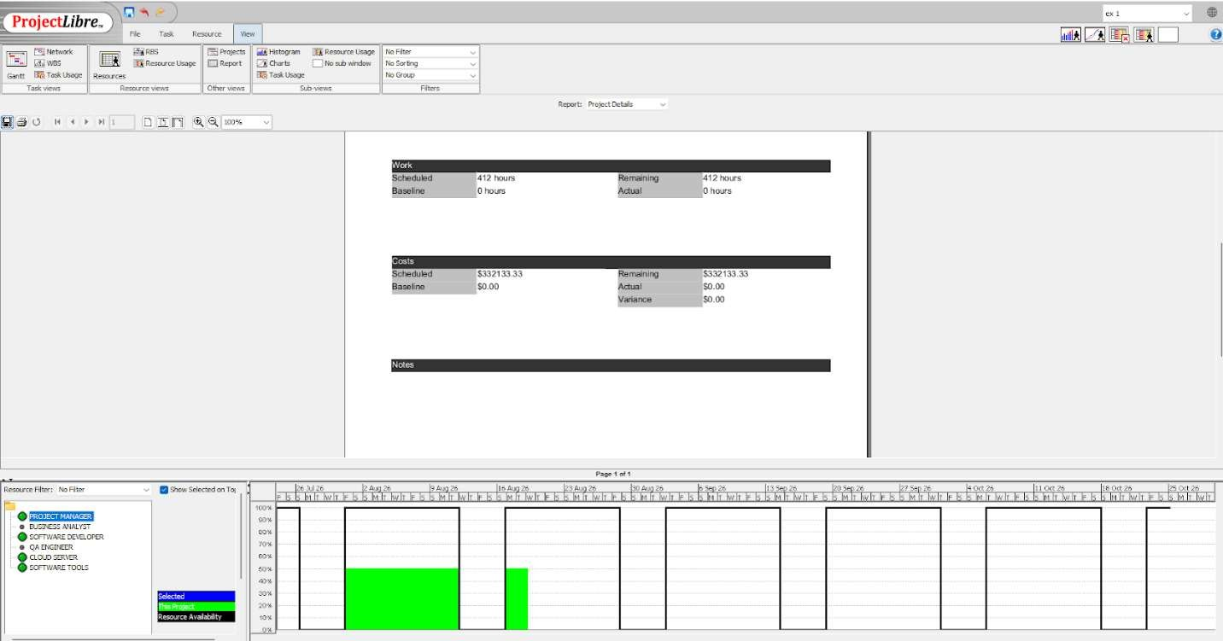
Algorithm
- Open ProjectLibre and create a new project.
- Enter the project tasks and durations.
- Set task dependencies (predecessors).
- Add project resources and assign them to tasks.
- Enter resource rates to calculate project cost.
- Generate the Gantt Chart and Network Diagram.
- Save the project.

Procedure:
- Launch ProjectLibre and create a new project.
- Add the required tasks with their durations.
- Define predecessor relationships between tasks.
- Create resources, assign them to the tasks, and specify their cost rates.
- Check the calculated project cost in the project reports/resource usage view.
- Save the project file.

OUTPUT:

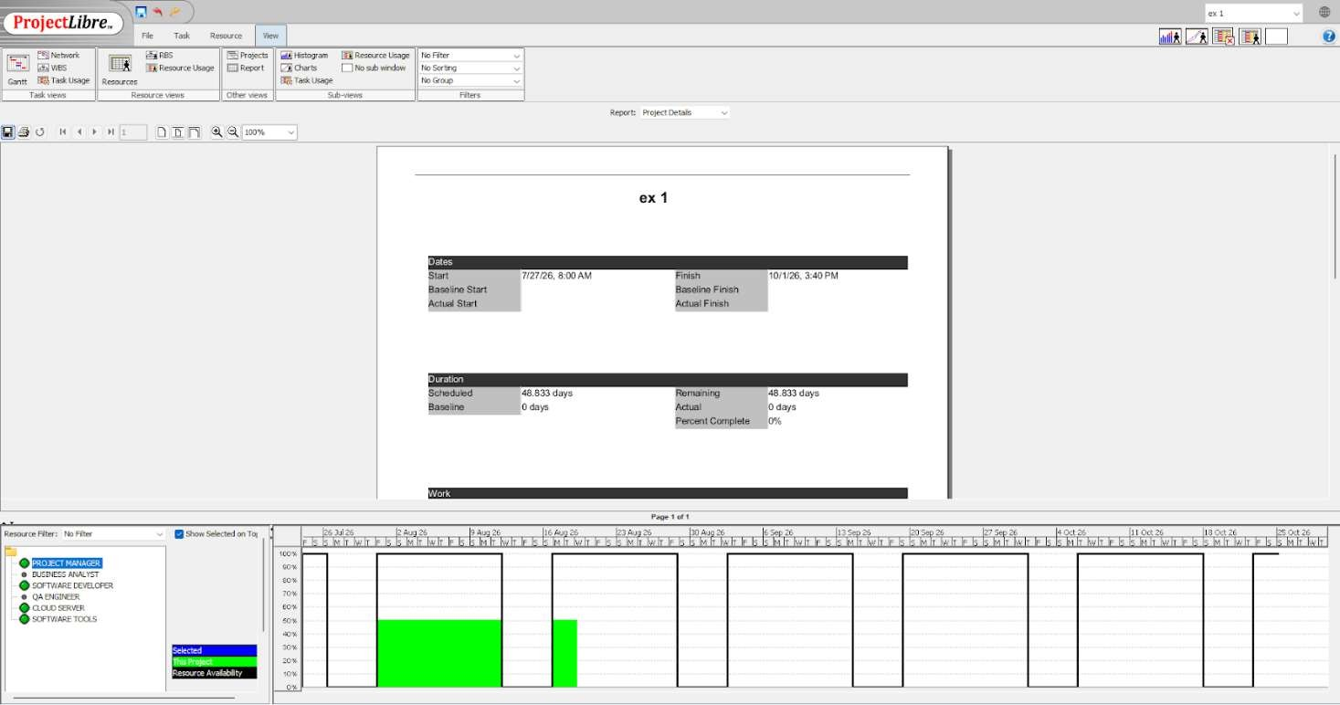
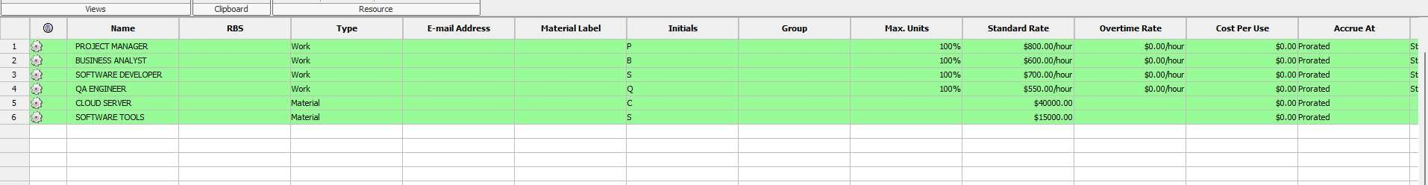
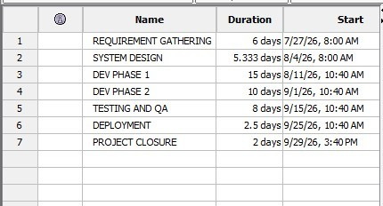
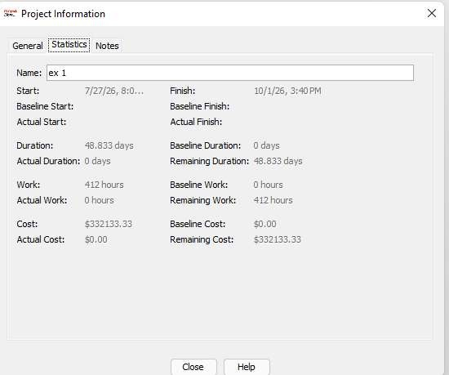
RESULT :
Successfully created a project schedule in ProjectLibre by defining tasks, assigning resources, establishing task dependencies, and calculating the overall project cost, resulting in an organized and efficiently planned project timeline.
PP

